CO project - GUI implementation ideas

Language for development: I found that Java Swing will do just fine for our purposes

YT link for learning how to work with Java Swing (seemed super nice so I decided to have it for everyone as a source): <https://youtu.be/Kmgo00avvEw>

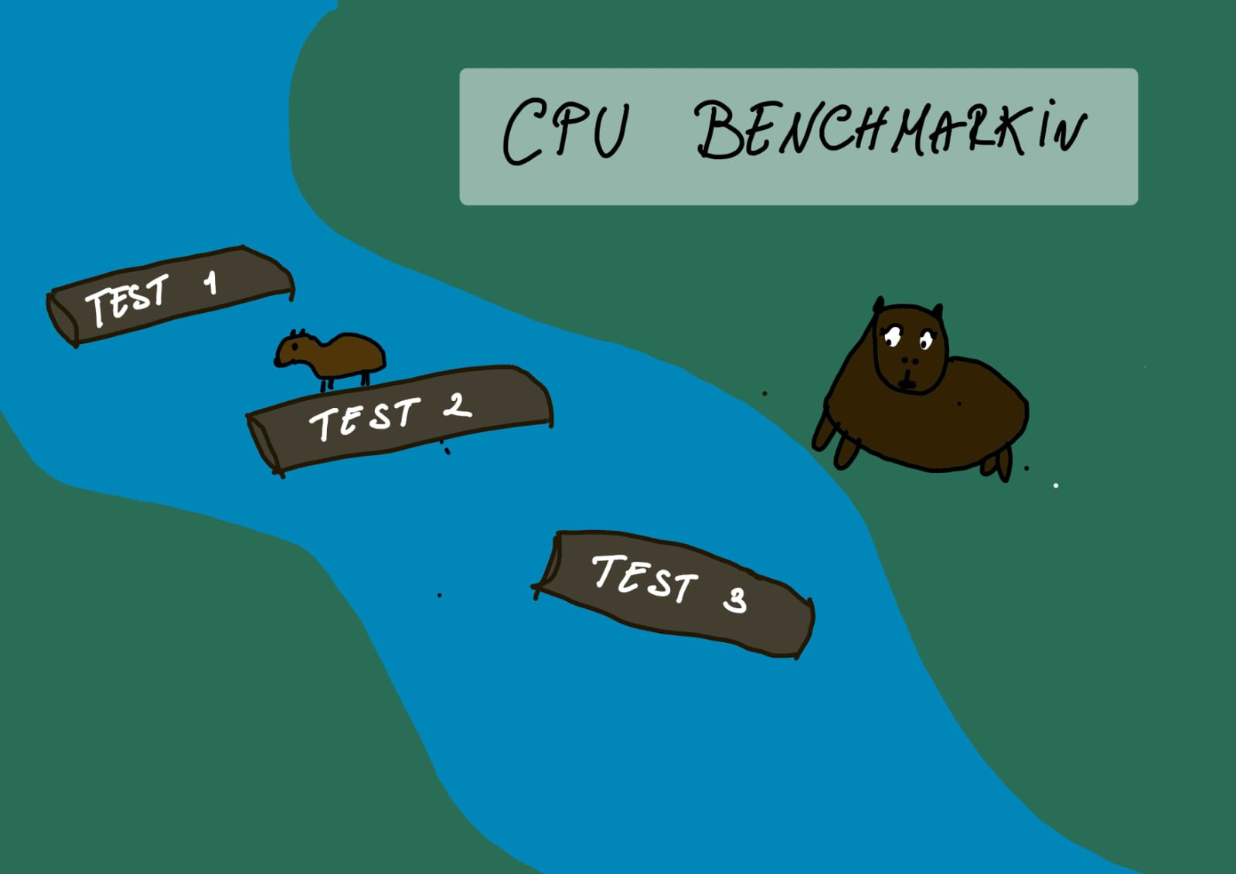Larisa’s creation that seemed super nice:

Her idea can be very simple implemented with a background, which I can take care of, being something creative, and I can handle it in the photoshop as well as other items for the icon of the program and so on.

I think the implementation itself will be ok to be done by everyone at least a bit of course if all of us wants, because is something new and we can all use to learn something new to add on CV.

About the actual structure of the interface I thought of this

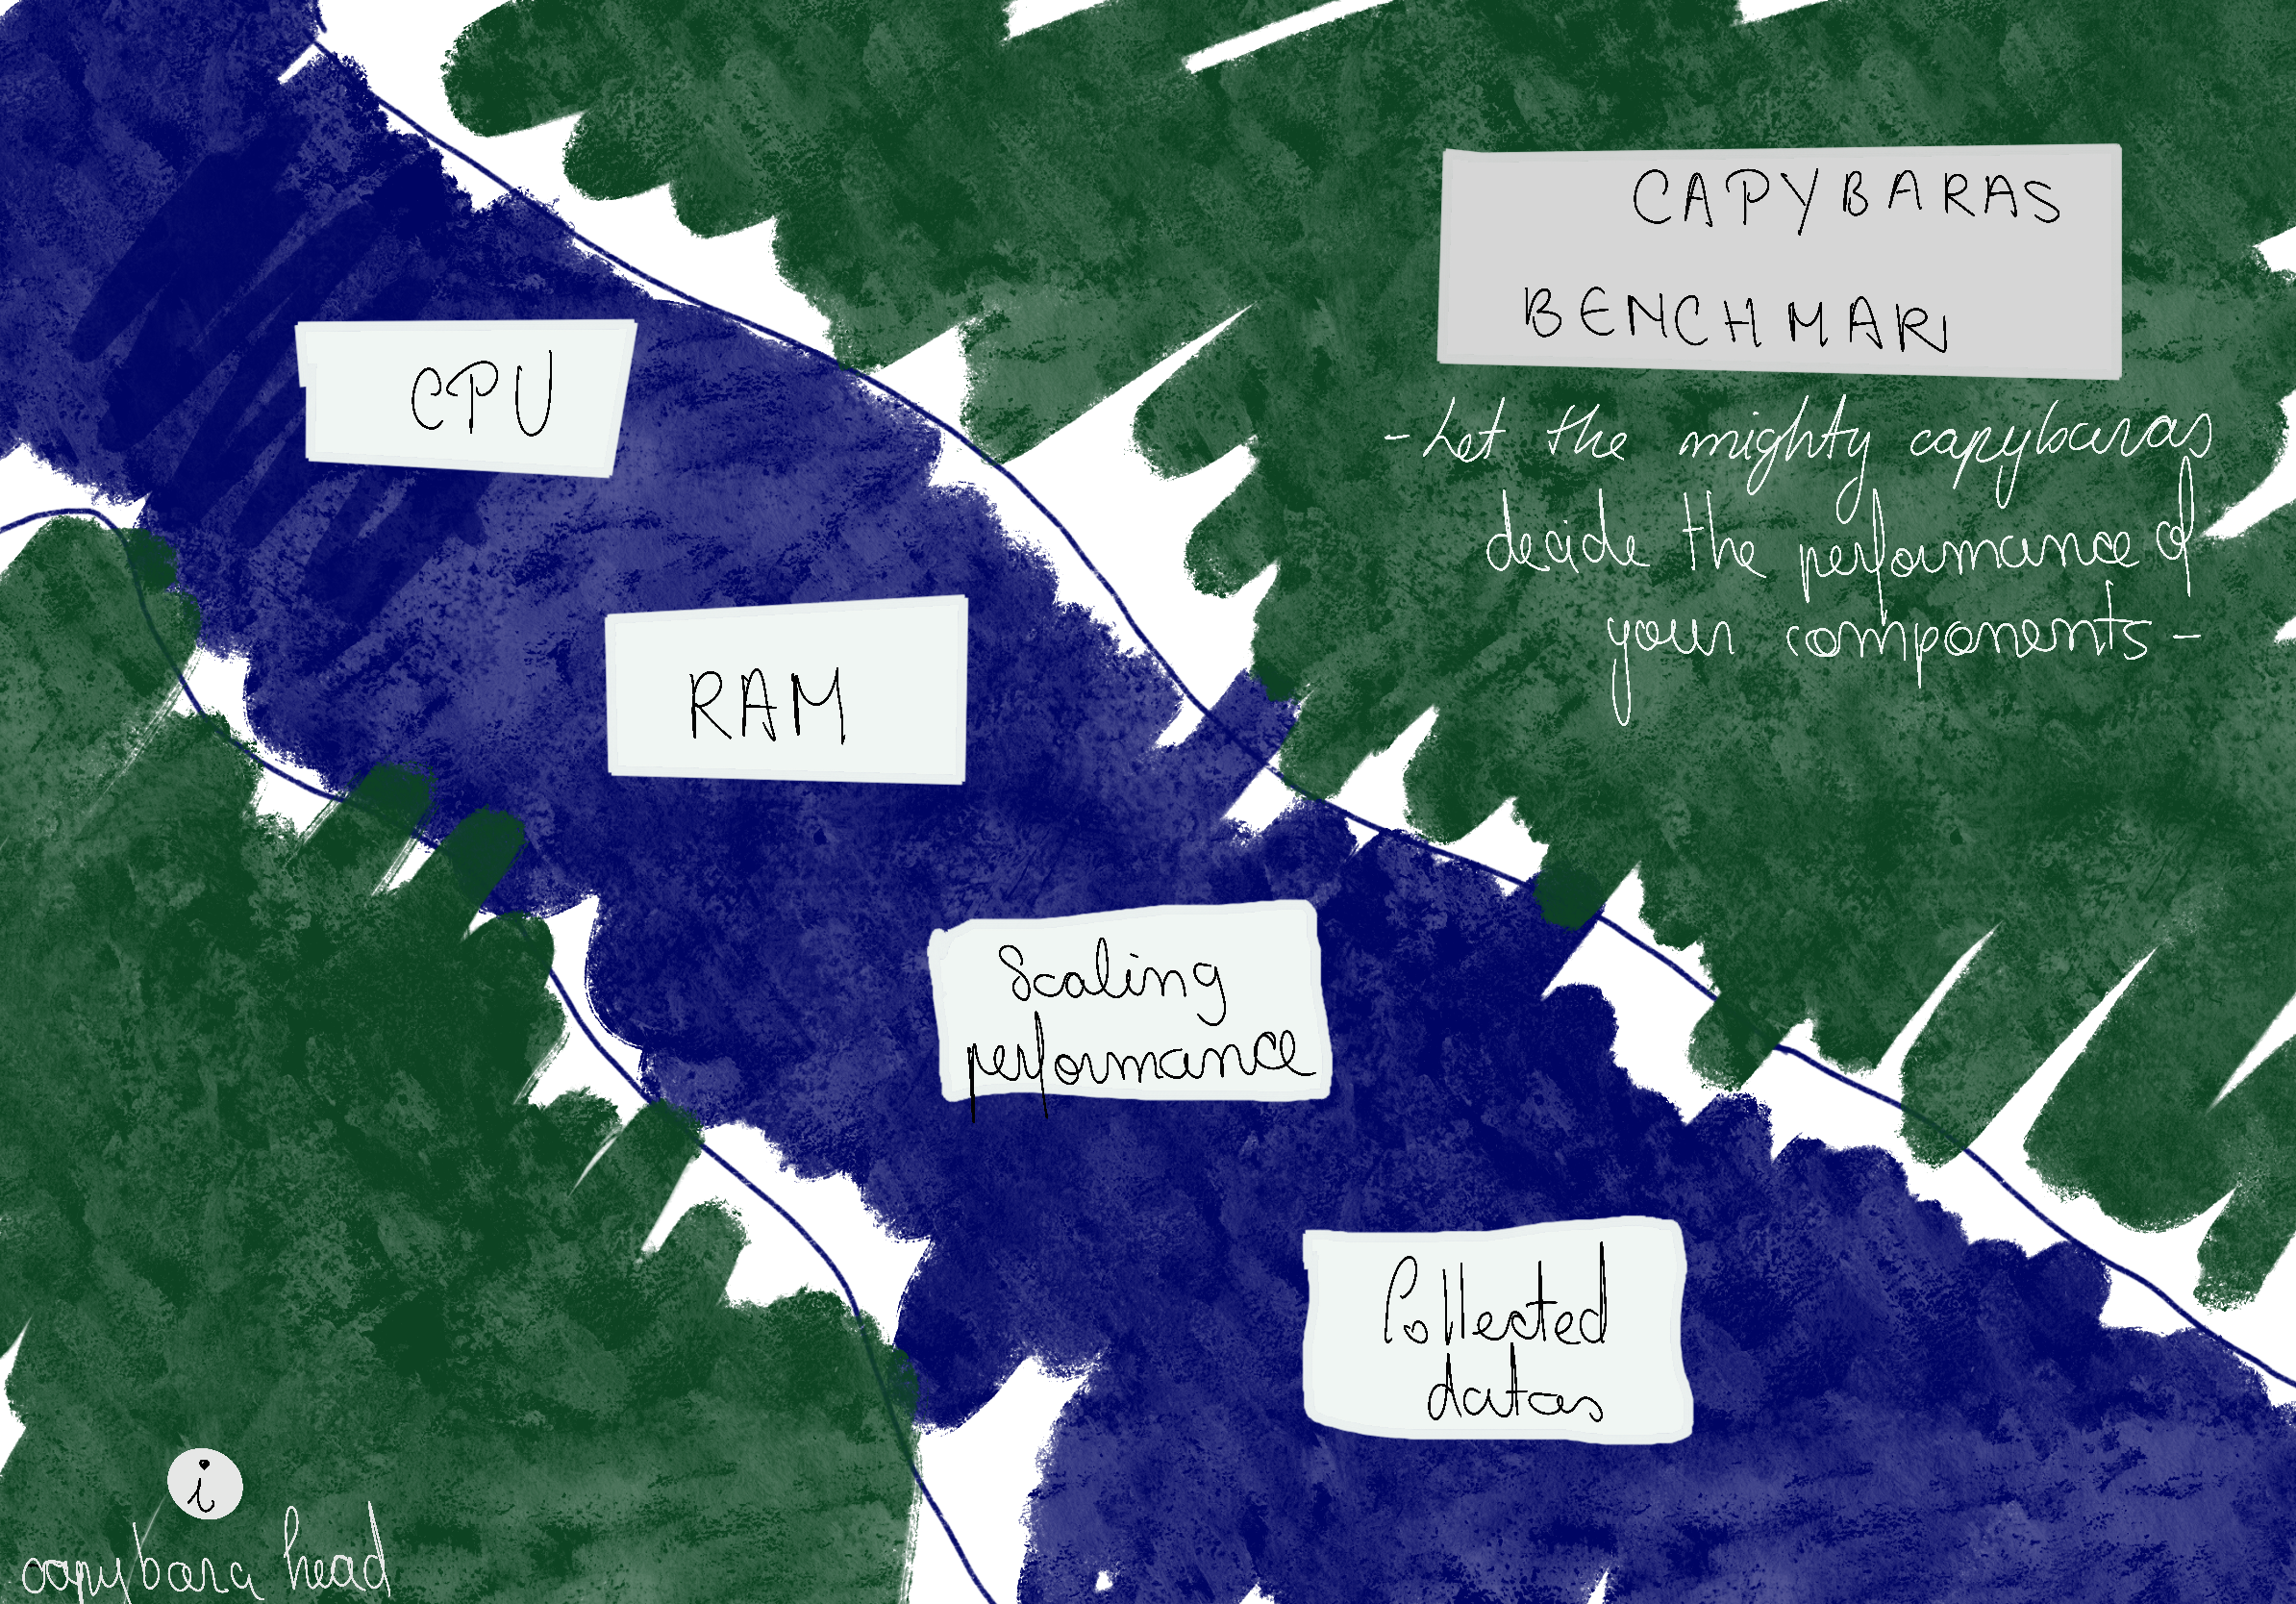

The name of the app: Capybaras benchmark

Also I think it will be nice to have like a motto: let the mighty capybaras decide the performance of your components

Main menu that will contain: the components that we want to test, or just one, that will be up to decide; the scaling performance that will show a graph of how the component is performing compared to the other ones we have in our database, and collected datasets that will be just an SQL in which we store the computers and the data about it that our app run for.

And as a last thing down in the left I thought of adding a capybara head with an info button that will have a short description about what the app does, and our names in it.

Don’t take into account the design, I just created a sketch for what Larisa made, to write more in detail the menu